Riphah International University Islamabad
Faculty of computing



Faculty of Computing

Hostel Management System

Project Team
Full Name of Student | SAP Id | Program | Contact Number | Email Address
Abdul Qadeer | 11055 | BSSE | 03055786731 | 11055@students.riphah.edu.pk
Akhtsham Kiani | 2330 | BSSE | 03461181503 | 2330@students.riphah.edu.pk

Project Title: [Hostel Management System]

Opportunity & Stakeholders:

The manual system consumes more time in record management. We are not able to manage the security of records. The motivation is to develop an automated system that can manage all tasks of the hostel in the quick manner. So, that it can provide ease to the management. Admin, staff and students are the stakeholders of this system.

Existing System/ Description of the Current Situation:
We are designing an Hostel management system Desktop Application. Its use to easy some hostel purposes for admin in our system. Before this system was developed, the records are managed manually. The manual management of records takes a lot of time. The time is wasted in order to gather all records and preparing a report on daily tasks. It is very difficult to coordinate with the other departments. Different activities are performed multiple times due to lack of coordination among management. This manual management of records makes it very difficult for the hotel management in taking decisions at various levels. Admin save students records add rooms add staff add new menu etc.

Problem Statement:
The system provide a solution for hostel management system to manage
All activities in a hostel including room management, students’ registration process manage staff, mange all dues and payments without using papers. The current manual system consumes more time in the booking of room. It is difficult to handle large amount of data manually and to maintain the security due to data loss. The data can be viewed by any unauthorized person. The current system is not able to provide secure registration of students. When we write information on paper, then information can be lost permanently if documents is misplace. It is difficult to handle large no of students and their records. It is very difficult to identify the record of any specific students due to large no of files. Human computational errors also occur, and it is a major issue due to improper calculations. Large space is required to store all the files. Due to large no of files, dues calculation is extremely difficult for the hostel management.

Proposed Solution:
Our proposed solution Hostel Management System is an automated system that allows hostel management to manage all activities of the hostel in an efficient manner. This project is aimed at developing a system for keeping records and showing information about or in a hostel. This system will help the hostel admin to be able to manage the affairs of the hostel. This system will provide full information about a student in the hostel. It will show rooms available or not and number of people in a particular room. This application provides the flexibility to manage the entire operations of the system. This system has an ability to manage hostel information, room booking and also it provides facility to manage students and staff information that makes this system very flexible and convenient. This system is useful for student, staff and admin to manage the activities of the hostel in a good manner. Admin can access all the system functionalities without any restrictions; HMS system manages daily tasks of the hostel. This system will be able to handle many services and provides these services to the students in a quick manner.
Scope of the Project:
Hostel management system is designed to manage all hostel activities like hostel admissions fees room mess allotment hostel stores & generates related reports for smooth transactions. It is also used to manage monthly mess bill calculation, hostel staff payroll, student certificates etc.

Following are the modules of hotel management system:
Modules of the System:
- Manage student
- Registration of student: Admin can register student by adding their information full name, address, phone no.
- View student Details: Admin can view the details of customers.
- Search student: Admin can search the student by using student id.
- Login
- Admin Login: By using email and password admin can login to the system.
- Room Management
- Add Room: Admin can add new room by adding information room no, room rent, room capacity.
- Assign new Room: Admin can assign new room to student by using room no.
- Checks Room Availability: Admin can check whether seat is available in which room for student.
- View Record: Admin can view the record of rooms.

- Admin Management
- Hostel Profile: Admin can add the details of the Hostel. It includes hostel name, address and contact no.
- View hotel information: Admin can view hotel information it includes hotel name, address and contact no.
- Menu Management
- Save Menu: Admin can save the menu details by using name, price and quantity of menu item.
- View Menu: Admin can view the menu details.
- Manage staff
- Add staff: Admin can add new staff by entering the information name, age, phone no, address, experience, pay, timing to, timing from and work duties.
- Search staff: Admin can search staff by entering staff id.
- View staff details: Admin can view staff details.
- Delete staff record: Admin can delete record of staff by entering staff id.

Project Plan

Work Breakdown Structure: A work breakdown structure (WBS) is deliverable based decomposition of project scope. The WBS includes 100% of the work defined by the project scope and captures all deliverables – internal, external, interim – in terms of the work to be completed, including project management.

- Project Management
  - Work Breakdown Structure (WBS)
- Hostel management system
Requirement
Analysis
Design
Implementation
Testing
Maintenance

Roles & Responsibility Matrix
These are roles assigned to the team in the project.
- Requirement Engineer: The requirement engineer (Abdul Qadeer) will elicit the requirements of our system. He will be responsible to elicit, understanding of requirements, coordination and communication among the management.
- Analyst: Abdul Qadeer (Analyst) will analyze the requirements of our system. He will be responsible to analyze the requirements in order to identify the problem.
- Designer: Akhtsham kiani (Designer) will transform requirements in to design. He will design the modules and components of our system.
- Developer and Tester: Akhtsham kiani and Abdul Qadeer both implement system and Focus to test the functionality of system. Both will implement the requirements and then perform the testing of our software.
- Change management engineer: Akhtsham kiani (Change management Engineer) will do repairs and fixes of the system. He will be able to do modification in the system after delivery and to improve the faults in the system.

- Reports / Documentation
  - Final Documentation Introduction
Our system is developed for those hostels that are currently using manual system to handle day to day tasks. The users involved in our system include Admin and Student. Admin can access all the functionalities of the system without any restrictions. This system has an ability to manage hostel information, room booking and also it provides facility to manage students information that makes this system very flexible and convenient. The final documentation of our system includes the following steps:
- Requirement
- Analysis
- Design
- Implementation
- Testing
  - Literature / Markey Survey
  - Our system provides unique facilities to the user as compared to the previously developed systems. The previous systems provide limited functionalities. Our proposed system provides functionalities that is beneficial for the customers and admin. It also helps us that how our customers will get aware of our software and how they can understand the value and uniqueness of our software. Our software will also play an important role in room bookings and menu management facilities. We will deliver this software so that the hotel management can manage their tasks by using our system.
  - Requirements Analysis
In requirement analysis we will analyze the requirements of a system. (Use cases)
- System Design
- Domain model
- Class diagram
- ERD diagram
- Implementation
In this phase of our project, we will implement our system.

- Conclusion & Outlook:
The proposed system is a user-friendly system and it also has some security constraints. The hostel management system can manage daily tasks in an efficient way. The benefits of our proposed system are as follows:
- Our system enables easy modification of data.
- It enforces security measures to avoid unauthorized access to the records.
- It enables fast and efficient access to the room booking records and also for other functionalities of the system.
- It avoids data entry errors.
- It ensures efficient communication within the hostel.

- End User Documentation

In the end user documentation, we will provide guidelines to the user about the working of software

- Application Admin Documentation
This document will help the admin about how to handle the system and it also provides him guidelines about the working of system at admin end.

- System Administration Documentation
This document will help the management and support activities. It also describes the development of the system. So, in this document we will guide about changes in the software so that if admin is in any trouble, he will get guidelines from this document.

- System
- Development Environment
- IDE We use Net Beans IDE for making our project
- Version Control
- Server
- Database
- Xampp
- MySQL

- Deliverable-1 Requirements In this deliverable, the requirement engineer will elicit the requirements of our system.

- Deliverable-2 Analysis In this deliverable, Analyst will analyze the requirements of our system.

- Deliverable-3 Design In this deliverable, Designer will transform requirements in to design.

- Deliverable-4 Implementation and Testing In this deliverable, we will do Coding of system and focus to test the functionality of system.

- Deliverable-5 Maintenance In this deliverable, Change management Engineer will do repairs and fixes of our software.

Roles & Responsibility Matrix:
The roles & responsibility matrix of our system is as follows:

WBS # | WBS deliverable | Activity # | Activity to complete deliverable | Duration of Days | Team member and roles
1. | Requirement | 1 | Eliciting the requirements | 14 | Abdul Qadeer
2. | Analysis | 2 | To analyze the requirements | 16 | Abdul Qadeer
3. | Design | 3 | Transformation of requirements into design | 20 | Akhtsham Kiani
4. | Implementation and testing | 4 | Coding of system and test functionality | 36 | Both
5. | Maintenance | 5 | Repairs of bugs in system | 10 | Akhtsham Kiani

Chapter 02: Requirement Analysis
2.1 Use case Model
In requirement analysis we will analyze the requirements of a system.
Use case
- Login
- Add room
- Fee record
- Add staff
- Add students
- Add menu
- Pay record
- Delete staff
- View staff
- Receive fee
- Pay staff
- View menu
- View students
- Delete students
- View room
- Logout

2.1.1 Use case Diagram
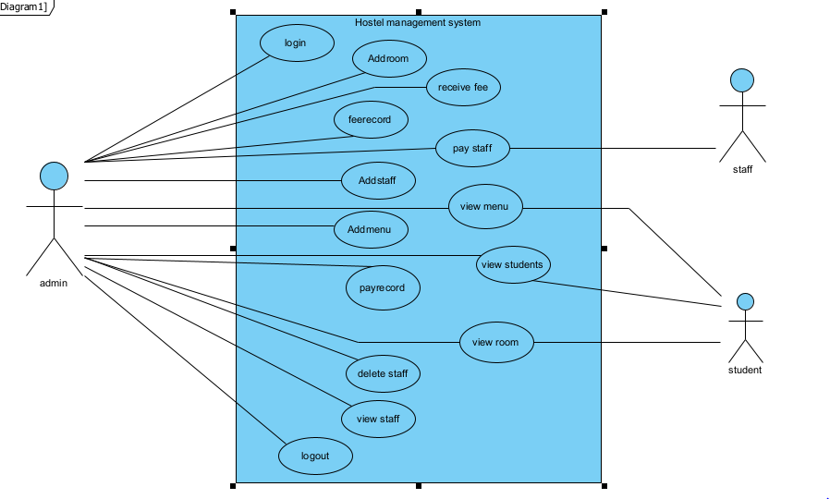

2.1.2 Use case specification
1.
Use case | login
Scope | Admin can login by entering valid email and password
Actor | Admin
Precondition | Admin enter valid information to login
Post condition | Admin logged in successfull

2.
Use case | Add room
Scope | Admin can add room detail
Actor | Admin
Precondition | Admin have to login and add room details
Post condition | Room details added

3.
Use case | Receive fee
Scope | Admin can received fee
Actor | Admin
Precondition | Admin have to login and confirm fee payment
Post condition | Fee payment is received

4.
Use case | Fee record
Scope | Admin save fee payment record paid by students
Actor | Admin
Precondition | Admin have to login and save fee payment record
Post condition | Fee payment record is saved

5.
Use case | Pay staff
Scope | Admin can made payments to staff
Actor | Admin and staff
Precondition | Admin have to login and made payment to staff
Post condition | Confirm payment and staff confirm

6.
Use case | Add staff
Scope | Admin can add new employee
Actor | Admin
Precondition | Admin have to login and add new employee detail
Post condition | Employee details added

7.
Use case | Add menu
Scope | Admin can add new menu
Actor | Admin
Precondition | Admin have to login and add details about breakfast, lunch and dinner
Post condition | Menu designed completely

8.
Use case | View menu
Scope | Admin and students can view menu
Actor | Admin and students
Precondition | Admin have to login and view menu
Post condition | Menu is visiable to students and admin

9.
Use case | View students
Scope | Admin andstudents can view student details
Actor | Admin and students
Precondition | Admin and students should select display button
Post condition | Students detail is visiable to students and admin

2.2 Domain Model
2.2.1 Finding concepts
Students
Admin
Hostel
Rooms
Staff

2.2.2 Finding attributes
Students
Name
Cnic
Phone No
Emergency phone#
Start Date
End date

Admin
Name
Password

Hostel
Name
Id
Fee

Rooms
Id
Number
Capacity

Staff
Name
Phone no
Joining date
Pay

Domain model diagram
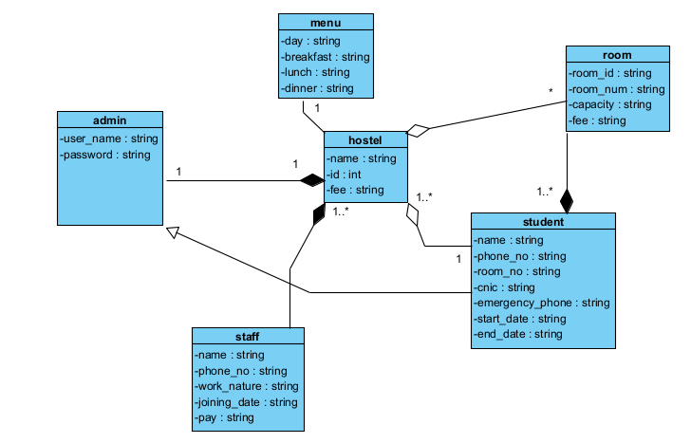

Class diagram
Classes
Hostel
Admin
Menu
Room students
Staff

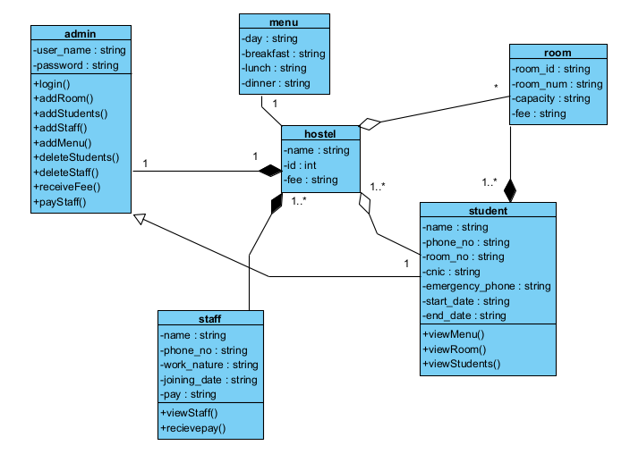

Sequence diagrams
Admin login

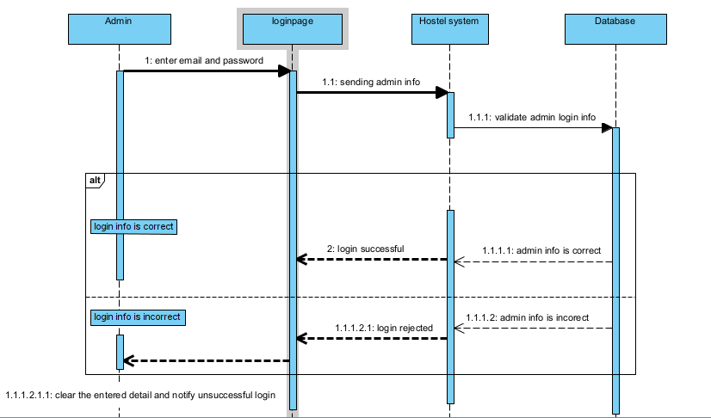

Seat confirmation

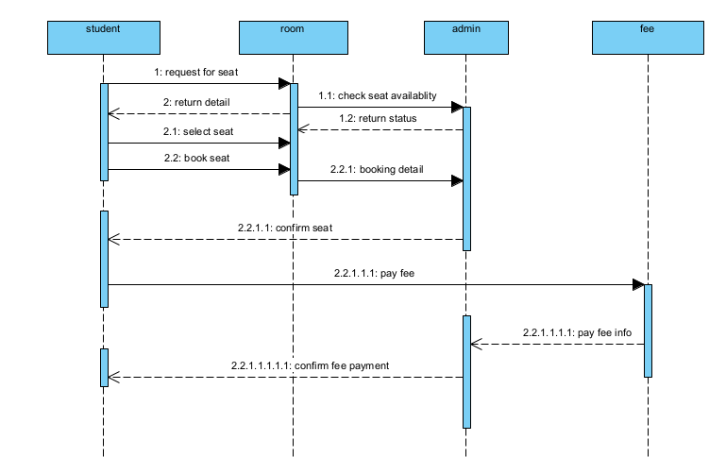

Add staff

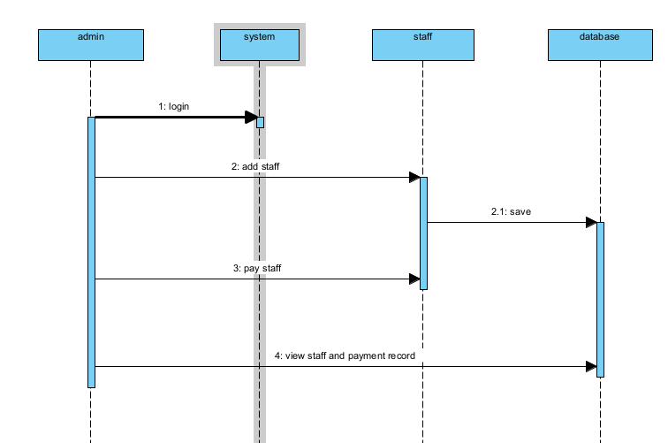

Add students

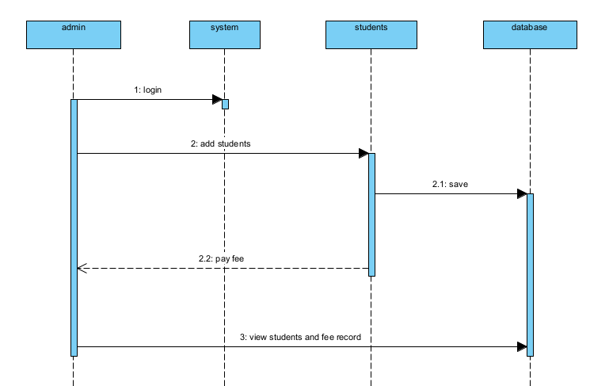

View menu

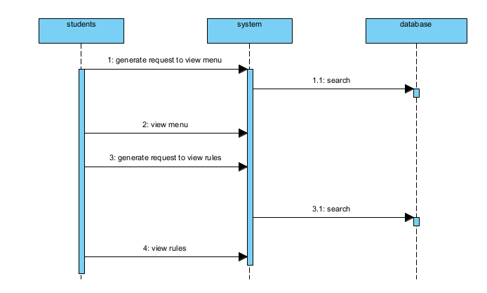

View detail

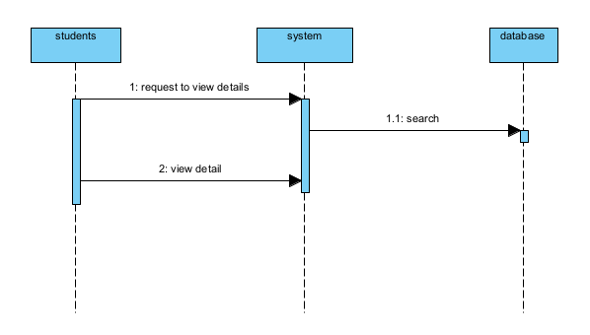

---------------------------------- THE END---------------------------------------

